Gameplay Abilities

Gameplay Abilities are actions or skills that an actor can perform

* Class derived from UGameplayAbility
* Defines what an ability does and the conditions under which it can be used
* Not implemented as a simple function; GAS game ability is an instanced object running asynchronously
* Can be activated at some point in time and run multi-stage tasks that may or may not span across a span of time
* These tasks could branch off into different tasks, apply their own gameplay effects, kick off **gameplay cues**
* Can be conditional, based on player or environmental interaction
* Gameplay abilities have built-in replication and prediction support
* Built in concept of cost and cooldown

## Ability Tasks

Gameplay abilities use ability tasks (although they don’t HAVE to)

* Ability tasks derived from UABILITYTASK
* Specialised form of UABILITYTASK
* Perform asynchronous work during a gameplay ability’s execution
* Can affect execution flow by broadcasting delegates
* Can be used in C++ or in BP through a specialised BP node
* BP node can have multiple output execution pins
* These are execute as a result of delegate broadcasts made in response to occurrences determined by developer – thing happens in game, task broadcasts delegate
* Can design the ability in the BP but make the actual work happen in code, very flexible

## Granting Abilities

To use a gameplay ability the ASC must be *granted* the ability

* GameplayAbilitySpec is created
* Spec defined details pertaining to that ability including
* GameplayAbility class itself
* Ability level
* Dynamic info that can be changed at run time
* Abilities granted on the server
* Ability spec then replicates to the owning client

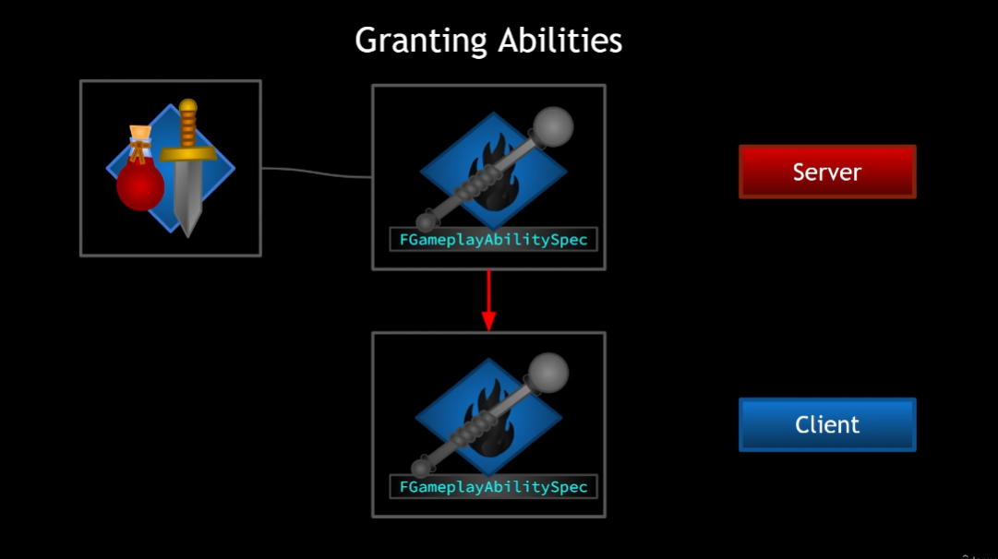

Gameplay Abilities have the concept of *Activation*

* Once activated, gameplay abilities are *Active*
* Until Ended or Cancelled
* Abilities can end themselves or be cancelled exernally

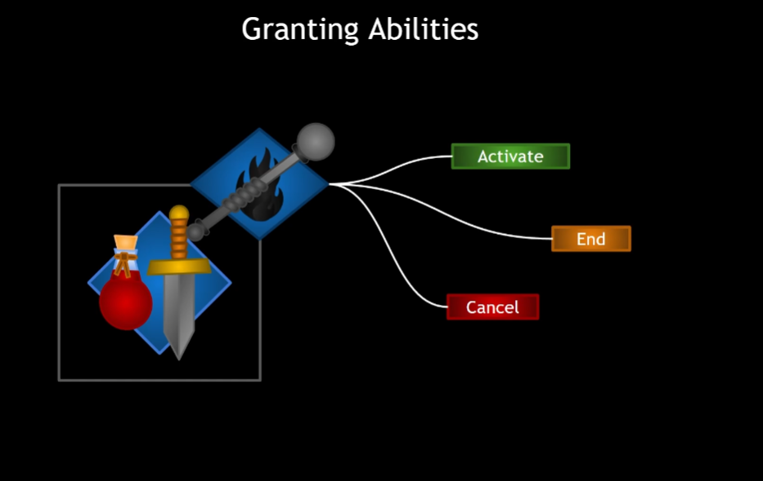

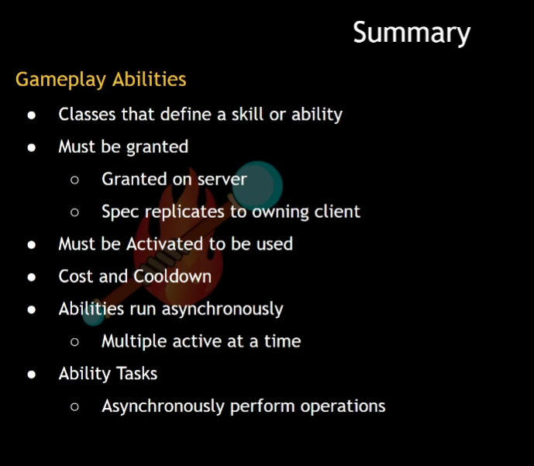

# Granting Abilities

Possible: Make a blueprint based on the gameplay ability class

Instead: create a base class of our own! That way all GPA we create will have the option to have some baseline functionality

Very basic template to start!

So, we want to grant abilities and this is done on the server

Let’s start by just giving the character a list of abilities that should be given at the start of the game

In AuraCharacterBase:

Add a TArray of GameplayAbility classes(type TSubclassOf)

Then we can set that TArray from within the character blueprint

So there will be an array of abilities, Now we need a way to *give* these abilities

This is done through the AbilitySystemComponent, so let’s add a function for adding those abilities

We may want to override in child classes so Protected

This function should only add abilities on the server, so we’ll do an auth check first

If we do have authority we want to:

Grant the ability; done by ASC, so let’s have the ASC actually do it; the CharacterBase will just call it

It should be public

The function will need to take in Gameplay Ability classes – this is the function we’ll call from CharacterBase

Since it’s a list of things we’ll loop through them

To add the abilities we need to create an ability spec from each of the ability classes



This is a struct that requires an ability class, so we’ll pass in AbilityClass

It also requires an ability level

Levels are just int32s. We’ll store the struct locally



And now we have the Spec, we can just use a function that exists on the ASC already called GiveAbility()



We could also give the ability and activate it immediately!

AbiltySpec *cannot* be const if we’re going to GiveAbilityAndActivateOnce!

GiveAbility will accept either

For the moment we’re gong to use ActivateOnce, because as a learning exercise I want to see what happens when an ability is activated and this is the easiest option that I know so far

Last thing to do here is call the function in AuraCharacterBase

To do this we’ll need to cast to the ASC

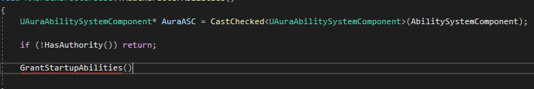

Nb this requires an include for the AuraASC.h

So, where to call AddCharacterAbilities?

For the player character, a good place is in PossessedBy (worry about enemy later)

Now we should see the ability added after InitAbilityActorInfo

We should expect, upon calling this function, to be granted all the abilities in the startup ability array

We can set the array of abilities here and there are some defaults, but I will make a new BP for the Abilities

It has Event Activate and Event OnEnd nodes

We can also use C++ functions, but we have events here

Testing:

Now, pressing play should grant and activate this ability on press play

Done, it’s active. But there’s no End Ability print string – Event OnEndAbility was never called!

Events can end themselves

# Settings on Gameplay Abilities

New GA_Test has been created, and is based on the C++ implementation of the Gameplay Ability class

Lots of options for the class defaults here:

Tags:

You can add multiple tags directly to the ability from this page:

Each item has a mouseover that comes directly from the comments in the gameplay ability class in C++ and are self-explanatory

Tags explained in WoW terms

* Abilities have the concept of having tags, and they can be added here But why do we want tags?
* Cancel abilities with tag
* This ability will cancel other abilities that have a specified tag
* Ice Block is removed when you Blink
* Block abilities with tag
* When you use this ability, you cannot use OTHER abilities which have the specified tag
* Eg you cannot Fireball while you are in an IceBlock (wow mage)
* Activation Owned tags: Ability puts a tag on the owner, which can replicate - there’s a setting in Ability System Global to turn this on
* Icy Fingers wow? Build up secondary resources/combo points/holy power etc
* Activation Required tags: you can only use this if the owner has all the required tags
* Finishing move requires the secondary points to use/Ice lance needs icy fingers etc
* Ability is blocked if activating actor has tags
* Stealth if tagged as ‘In combat’?
* Debuff that blocks an ability like Forbearance blocks Divine Intervention – use with Activation Owned tag to put a cooldown on a target instead of the ability itself
* Source Required/Source Blocked: limitations on when an ability can be activated
* Target Required: eg can only envenom if target has poison
* Target Blocked: eg Cannot knockback target if target is rooted?

If you press input/receive input every frame that is sent to the server…not performance friendly? Encourages button mashing

If we’re using Local predicted do we need to use a replication policy? Its set to Do Not Replicate; should we turn it on, or not? No, gameplay abilities are automatically replicated by default, no need to change this.

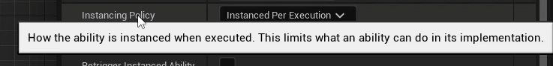

Gameplay abilities are classes that can be instanced.

Instanced per actor means we only make a single instance of the class upon activation. This one instance is reused every time it’s activated.

Since it’s instanced per actor, the actor is persistent, can store persistent variables and if you need to reset the variables you have to do it manually because the ability is never destroyed, it’s reused.

Instanced per execution: a new instance is created with each activation. Ability actor is created and destroyed over and over again. Does not store persistent data between activations because each activation creates a new instance of the class. Least performant option.

Non-instanced: class default object, no instances at all. Limited use, cannot store state, bind to delegates, never actually creates objects of this class. Like a static function library. Best performance.



“If you cancel this ability on the client, the server will be informed and will cancel it as well”

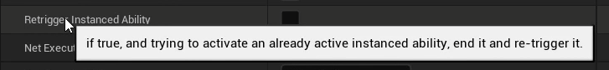

Self-explanatory, perhaps something like J-Boots from EQ?



4 options

Local only: client only, server does not execute anything. Good for cosmetic only things that do not affect gameplay

Local predicted: Takes time to travel to server, which can roll back invalid changes.

Server only: passive gameplay abilities you want running all the time/listening

Server initiated: runs on server then replicates.

In this project Local Predicted is fine for most abilities





Gameplay ability has a resource requirement directly related to attributes. Costs are implemented in the form of gameplay effects, so make a gameplay effect, select it here to connect them. Eg Mana, energy for WoW rogues, Breath for swimming under water etc

Allows the ability to be triggered in response to an event eg Reincarnation triggered in response to player death

Gameplay tag based:

Possible sources:

For example cleric resurrection

Gameplay effect based

# Input Config Data Asset

Immediate activation works, but it would also be desirable to activate abilities via input

To do: create a data asset that contains input actions but link up input actions with gameplay tags

At runtime we can assign various tags to gameplay abilities – as abilities are activated every ability is associated with the tag which can be checked and changed

Target: an array of input actions, nothing too complicated, but the input actions need to be linked to gameplay tags

Easy way to do this is how Lyra does it, a struct with an input action and a gameplay tag

Struct will contain an input action: will be a const and we’ll forward declare the class to avoid including the header file, and initialise as a null pointer

And a tag

Now that we have this struct our data asset can contain an array of these that we can set in the data asset blueprint

This array will be populated with input actions

Specifically AuraInputActions that have a gameplay tag

If we have a pointer or reference to this input config we can look up any actions that have a specific tag

Function to do this:



Why return an InputAction, not an AuraInputAction though? Because this will be more useful if we return just the InputAction associated with a gameplay tag, and so the struct is an internal element to the input config; we don’t have to worry about breaking it open and finding the action inside; we’ll do it here



This will return the input action associated with a given tag

Loop through the Ability Input Actions by const reference

For each action we check the association is not null and also if there’s an exact match to the given tag

Then



There’s also the bool for if we don’t find anything

And finally since we have to return a pointer, we’ll return a nullptr

So now we have a function to find an input action associated with a given tag, which only works if we link up tags to input actions by filling out the data asset

We also need Input tags for any of the inputs we want in the game

We can add these natively to AuraGameplayTags.h

And initialise in AuraGameplayTags.cpp

Tags are in the editor!

Add new data asset:

We can add new Ability Input actions, but we need to make the input actions first. They are one-dimensional IAs (move is 2)

IMC links physical input to IA

The Data Asset linking IA to tags

A little tedious but it means the data assets can be swapped out dynamically even at runtime